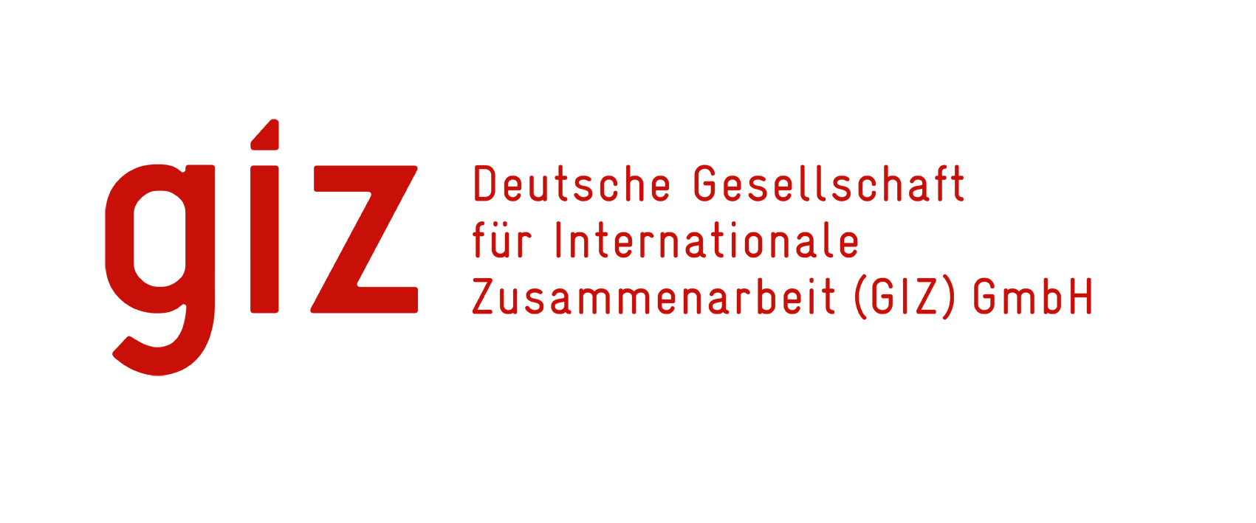

**VACANCY ANNOUNCEMENT**

**Project Description**

The GIZ “Cooperation for the Enhancement of SADC Regional Economic Integration” (CESARE) programme has been commissioned by the German Government (BMZ) and is a cooperation programme with the Southern African Development Community (SADC), represented by the SADC Secretariat. It builds on a longer history of previous projects working in similar thematic areas. The overall objective of the programme is “SADC member states have improved the preconditions for trade in the area of goods and services in line with the SADC industrialization

agenda.”

The project operates in different fields of activity including: elimination of non-tariff barriers (NTBs) to trade in priority regional value chains; implementation of the Trade Facilitation Program with a focus on trade-facilitation measures that are relevant for the industrialisation agenda; introduction of a system to facilitate small-scale cross-border trade; support for negotiations on trade in services in priority sectors and support to the SADC industrialization agenda.

Industrialisation within SADC came into sharp focus in 2014, when the Regional Block decided to place industrialisation at the centre of its regional economic integration as a strategy for attaining economic transformation of the Region. SADC’s aspirations to industrialise the Region are reflected in the “SADC Industrialisation Strategy and Roadmap: 2015-2063”. In response to the priorities of its partners, the BMZ through GIZ CESARE programme supports the SADC Industrialisation Agenda through various interventions. Consequently, the Deutsche Gesellschaft für Internationale Zusammenarbeit (GIZ) GmbH invites suitably qualified, experienced, innovative individuals to apply for the position:

**1.** **TECHNICAL ADVISOR – Industrialisation**

Job Title : Technical Advisor

Job Category : Professional, Band 4

Location : Gaborone, Botswana

Project : GIZ “Cooperation for the Enhancement of SADC Regional Economic Integration (CESARE)” programme

Duration : immediately until 30.11.2023

**Key Responsibilities;**

**Advising the partner institution**

* Provides professional advisory services to the SADC Secretariat in the different fields of project activities with a focus on the SADC industrialization agenda particularly value chain development and private sector development
* Supports the SADC Secretariat through technical and process-oriented advice as well as supports and monitors the development and implementation of project/programme plans and activities relevant for the industrialization agenda
* Provide advisory services on building the productive and manufacturing capacity of SADC Member States
* Prepares and implements the coordination process, joint project/programme activities and work at the regional level also on new approaches towards industrialization (e.g. B2B Platforms, E-commerce, ICT etc.)
* Performs stakeholder analyses and support the selected sectors and selected companies for export and intra-regional trade potential
* Prepares concept papers and roadmaps for program implementation
* Supporting the Private Sector in SADC MS with innovative business models, specifically public private partnerships, private sector-led management and operation to implement the SADC industrialization Agenda;
* Developing knowledge and share lessons of SADC key priority sectors with the potential of value chain related employment opportunities to women and youth;
* Carrying out policy dialogue for a business enabling environment for the sector areas of work, which includes the legal, regulatory and institutional framework;
* Guide the development of functional and technical specifications, project designs and feasibility studies
* Coordinate research/studies to identify industrialization strategy, NTBs, policy and regulatory gaps in the region.
* Identify key areas of interventions to promote industrialization and competitiveness in the SADC region
* Facilitate and coordinate implementation of capacity building initiatives in industrial development and Trade at SADC Secretariat and in Member States; monitor and evaluate the success of the interventions

**Knowledge management**

* Knowledge management as well as participation in the public relations work of the projects.
* Prepares appropriate input for various project/programme reports including annual reports, and contributes to the other reports required by the programme manager and GIZ Head Office
* Carry out research activities and studies on technical issues which benefit joint programmes.

**Networking and Cooperation**

* Supports cooperation, regular contact and dialogue with partners, assists with Public Relation work and cooperates with e.g. relevant organisations, non-governmental agencies and individuals in the project/programme environment and with other projects to improve and maintain good working relationships
* Performs other related duties and tasks at the request of management
* Build strategic networks with relevant officials in SADC MS and at the SADC Secretariat as well as from the private sector to ensure effective implementation of projects and activities

**Coordination of tasks**

* Supports the general project planning and develops project concepts including preparation, organisation and moderation of planning exercises and their implementation, management, monitoring, quality management, evaluation, communication and documentation
* Effectively contribute to coordinated delivery of technical assistance in the area of industrialisation through building strategic partnerships and collaboration with other development agencies, ICPs to ensure value for money and avoid duplication of efforts

**Requirements:**

**Qualification**

* Advanced Degree in Economics, Development Studies, Marketing, Production Management, Industrial Engineering, International Relations, Political or Social Sciences, Law, Organisational Development, or any related discipline. Good knowledge of international economics and trade theory with a focus on the above-mentioned fields of activity of the project.
* Bachelors’ Degree may be considered if accompanied by relevant work experience.

**Professional experience and skills**

* At least 5 years of work experience in the area of industrialization and industrial policy development and implementation
* Experience in innovation and Technical Advice in designing and implementing partnership models between public and private sector
* Proven work experience in ICT based approaches towards industrial policy e.g. e-Commerce, industry 4.0 etc.
* Experience in policy formulation and implementation of strategies
* This is an advisor-level position requiring proven experience in international development field implementing regional integration initiatives and projects (knowledge of GIZ systems is an advantage).
* The Technical Advisor- Industrialisation is expected to carry out project activities independently
* Demonstrable understanding of the relationships and interplay among investment production/industrialisation and trade/market within the context of regional economic integration
* Demonstrated ‘hands on’ results-based project development, management and monitoring experience in the development sector in the SADC region.
* Understanding of the political, economic and social dynamics in SADC and the complex factors impacting the ability to implement and achieve strategic outcomes.
* Technical knowledge and experience on policy, strategy, sector facilitation, value chain analysis and development, analysis of industry, trade, investment and other related policies.
* Good appreciation and understanding of the binding constraints to industrialisation in the SADC region and ability to formulate sound recommendations for implementation
* Excellent communication and negotiation skills, especially in dealing with government officials, non-state actors and ICPs in the SADC region.
* Demonstrable track record of production of various publications targeting various audiences on international or regional platforms particularly in SADC region.
* Familiarity with capacity development approaches to organisational development is essential
* Experience with GIZ technical cooperation approaches, support delivery processes, and advisory instruments and services.
* Knowledgeable of the e-Commerce space that includes marketing strategies, product development, competitive strategies, consumer research, industry trends and usability best practices.

**Other knowledge, additional competences**

* Very good knowledge of ICT technologies and computer applications (e.g. Microsoft Office, MS Teams, Project Planning Tools)
* English proficiency is required (written and oral). Knowledge of French, German and/or Portuguese an advantage.
* willingness to upskill as required by the tasks to be performed – corresponding measures are agreed with management Excellent communication and collaboration skills.
* Analytical and multitasking skills.

Applications should be addressed to: The Human Resources Manager

P / Bag X12, Village

Gaborone

E-mail address: hr-botswana@giz.de

OR

Hand delivered to: 1st floor Morula House, Plot 54358, Prime Plaza, New CBD, Gaborone

**Closing date for application is 13th September 2021.**

**For further information please contact HR unit at 3957400**

Please note that only shortlisted candidates will be contacted.

*GIZ Botswana is an equal opportunity employer, therefore it encourages applications from all qualified and eligible candidates regardless of their gender, religion/belief, origin, disability, and/or any other minority group. We are committed to creating an inclusive working environment for all employees.*