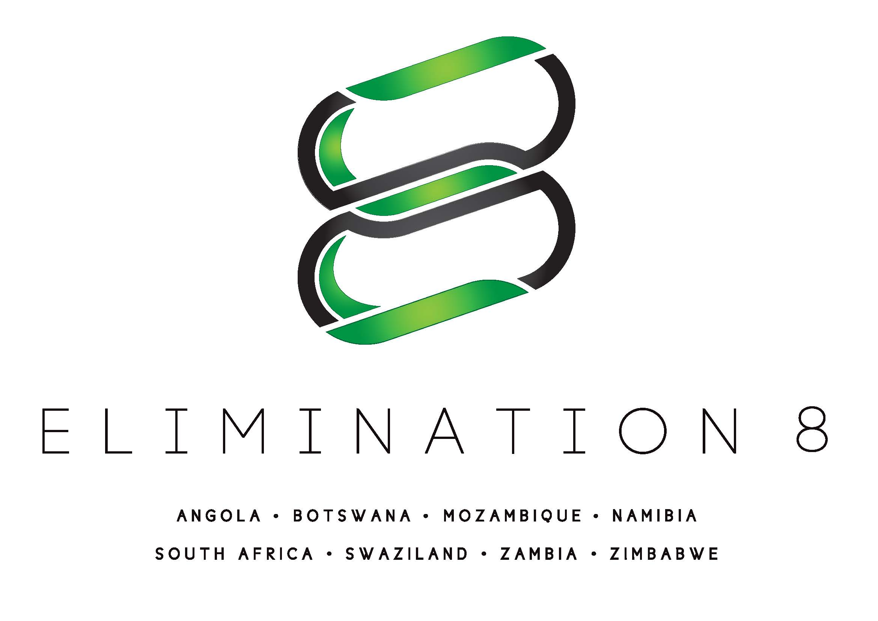

REQUEST FOR PROPOSALS E8-PSM-001-2016

Third Party Logistics Service Provider (3PL)
for Health Commodities

ACRONYMS

3PL Third Party Logistics

ACT Artemisinin-based combination therapy

E8 Southern Africa Malaria Elimination 8 Initiative

LMIS Logistics Management Information System

MoH Ministry of Health

OSDV On-Site Data Verification

POD Proof of Delivery

PPM The Global Fund’s Pooled Procurement Mechanism

PSM Pharmaceutical Supply Management

QA/QC Quality Assurance/Quality Control

RDT Malaria Rapid Diagnostic Test

RFP Request for Proposals

RIRV Requisition Issue and Receipt Voucher

RQSA Rapid Quality of Services Assessment

SADC Southern African Development Community

The Global Fund The Global Fund to Fight AIDS, Tuberculosis and Malaria

REQUEST FOR PROPOSALS (RFP) OVERVIEW

RFP No: E8-PSM-001-2016

RFP Title: Third Party Logistics Service Provider (3PL) for Health Commodities

RFP Issued By: Southern Africa Malaria Elimination 8 Initiative Secretariat (E8 Secretariat), with funding from the Global Fund to Fight AIDS, TB and Malaria

Issuance Date: 06 June 2016

Registration for Information:

To ensure you receive modifications to the RFP, send an email to procurement@elimination8.org requesting that your company be put on the distribution list, with the RFP number included in the subject line.

There will be no pre-proposal conference. Questions can be directed to procurement@elimination8.org. Registered entities will receive periodic frequently asked questions and answers.

Submission of Questions regarding the RFP:

Questions regarding the RFP should be submitted by email to procurement@elimination8.org by 17 June 2016. The E8 Secretariat will send answers to questions to all registered parties.

Proposal Submission Deadline:

23 June 2016, 17:00 hours Central African Time. All proposals should be electronically submitted to procurement@elimination8.org.

Language of Proposals:

The technical and cost proposals must be submitted in English.

Instructions for Submission of Proposals:

Separate technical and cost proposal files must be submitted to procurement@elimination8.org with the RFP number in the subject line. The files must be in Word, PDF, or Excel formats.

Estimated Period of Performance:

The period of performance is two years, with an estimated contract award date of July 2016. There will be a one-year base period and a one-year option period. The option period will be invoked if the 3PL Contractor’s performance and achievement of indicator targets is acceptable. The option period is also subject to available funding.

Awards:

It is anticipated that there will be one or more fixed unit price awards.

Issuance of this Request for Proposals does not constitute an award commitment on the part of the E8 Secretariat nor does it commit the E8 Secretariat to pay for costs incurred in the preparation and submission of a proposal.

Code of Conduct:

The Global Fund to Fight AIDS, Tuberculosis and Malaria’s Code of Conduct for Supplier is applicable to this solicitation and any subsequent award. It is available at www.theglobalfund.org

TERMS OF REFERENCE

Background

The Southern African Malaria Elimination 8 (E8) Initiative is a coordinated, eight-country effort to achieve the historic goal of eliminating malaria in four southern African countries by 2020 (Botswana, Namibia, South Africa, and Swaziland), and to subsequently pave the way for elimination in four more by 2030 (Angola, Mozambique, Zambia, and Zimbabwe). The frontline four countries – Botswana, Namibia, South Africa and parts of southern Zimbabwe - have suppressed transmission and reduced malaria incidence to less than 2 cases per 1,000. However, the persistence of malaria transmission is largely caused by ongoing transmission in border areas as a result of the importation of infections from across the borders, where malaria transmission is higher, and access to health services is sometimes limited. The combination of these factors – (i) higher malaria transmission, (ii) low access to early diagnosis and treatment of malaria, and (iii) high volumes of human movement across southern Africa’s porous borders - facilitates the continued movement of parasites into the eliminating areas, serving as one of the key barriers to attaining elimination. As they reduce malaria incidence, E8 frontline countries therefore remain vulnerable and receptive to malaria outbreaks triggered by imported cases from their neighbors, the second line countries.

The Elimination 8 Secretariat was established in Windhoek, and serves as the coordinating and implementing arm of the regional partnership. Elimination 8 is funded by The Global Fund to Fight AIDS, Tuberculosis and Malaria amongst other entities. The contract awarded from this Request for Proposals will be funded by The Global Fund.

Transmission in second-line countries is typically highest in northern regions/provinces, far from the borders with the frontline E8 countries. As a result, the priority for allocation of the national resources for malaria control is naturally given to those northern areas of the second line countries. Conversely, the highest burden areas for frontline countries are adjacent to those borders with second line countries. This creates a difference in spatial prioritization of malaria interventions between neighboring countries, as the second line countries give less priority to their southern borders, yet it is these same southern borders that are the cause of persistent importation for the frontline countries.

.

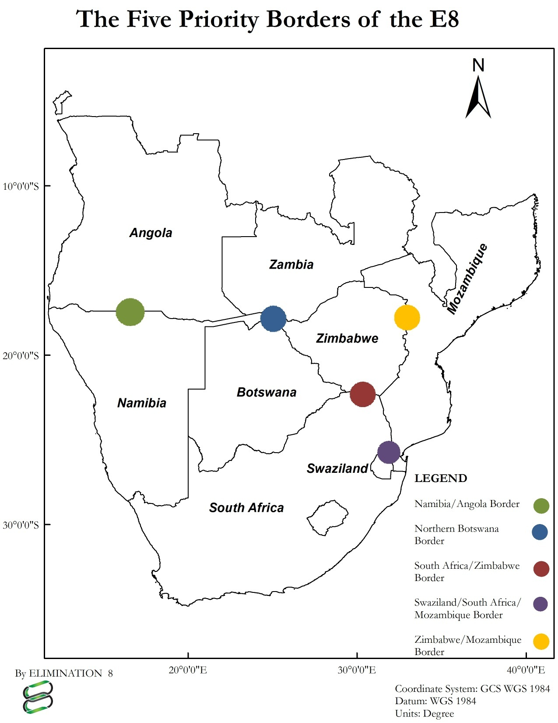

Health Commodities

The following health commodities will be procured by the E8 Secretariat through The Global Fund’s PPM and delivered to ports of entry in Angola – Luanda (either 4 de Fevereiro International Airport or Luanda Sea Port), Mozambique - Maputo (either Maputo International Airport or Maputo Sea Port)and South Africa – Johannesburg (either O. R Tambo International Airport or Durban Sea Port) for use in Angola, Mozambique and South Africa respectively. The governments of Botswana, Namibia, Swaziland, Zambia and Zimbabwe will provide health commodities in their respective countries from the designated Central Medical Stores. The E8 Secretariat will facilitate the availability of the commodities with the MOH in the countries where the countries are providing the health commodities.

- Artemether/Lumefantrine tablets or other approved artemesinin-based Combination Therapy (ACTs)
- Malaria Rapid Diagnostic Tests (RDTs)

Services Required

The specific objective of the award from this Request for Proposals (RFP) is to provide shipping, customs clearance, storage and timely distribution of health commodities procured either through The Global Fund’s Pooled Procurement Mechanism (PPM) to be used in Angola, Mozambique and South Africa The Global Fund’s PPM delivers as far as the ports of entries Luanda in Angola, Maputo in Mozambique and Johannesburg in South Africa. The 3PL Contractor must provide long haul distribution to appropriate climate controlled storage areas in each country near the border areas from where they will either be delivered by the 3PL Contractor to service provider storage facilities or from which the service provider will pick them up.

As stated above, for last mile distribution, either the service providers will pick up the commodities and store them in their own medical warehouses for eventual distribution to the border area malaria facilities or the 3PL Contractor will transport them to the service providers’ medical warehouses. The ultimate locations of the facilities in the border areas are generally known (see graphic above) but exact locations will not be known until the service provider contracts are finalized.

Customs Clearance

The 3PL Contractor will clear commodities procured through the PPM through customs in Angola, Mozambique and South Africa. The E8 Secretariat is entering into a Memorandum of Understanding with each country to formalize the agreed upon waivers of all customs and other taxes and duties at point of entry that might otherwise pertain to health commodities, drugs, and supplies being moved by the E8 Secretariat to carry out its functions. The respective countries also will waive any non-tariff procedural requirements and reports that may delay the free and timely movement of health commodities, drugs, supplies, and test samples across borders.

The 3PL Contractor will:

- Ensure timely customs clearance of all the commodities within five days of entry.
- Ensure compliance with country level regulatory requirements for importation of health commodities. This requires close collaboration with the E8 Secretariat and other stakeholders, like the relevant drug regulatory and revenue authorities to ensure that all the requirements for clearance are met in a timely manner.
- Coordinate with the country level health ministries (or equivalent) to ensure completeness and accuracy of importation documents for commodities.
- Constantly review and keep the E8 Secretariat informed of requirements for importation in each of the target countries.

Storage of Commodities

- Ensure proper inspection of all incoming health commodities to ensure that quality has been maintained during shipping. Where applicable, the 3PL Contractor will, in close collaboration with the E8 Secretariat and the respective country’s drug regulatory authorities, arrange for post shipment testing through approved laboratories. The cost of health commodities quality control testing will be covered by the E8 Secretariat or prior in agreement with the E8 Secretariat.
- Ensure that the commodities are stored under the manufacturer recommended ambient storage conditions as per the international standards for management of pharmaceuticals and health commodities including those from the World Health Organisation (WHO), The Global Fund and country level drug regulatory agencies.
- Ensure appropriate inventory of the commodities is maintained at all times.
- Support continuous reviews by the E8 Secretariat including On-Site Data Verification (OSDV) and Rapid Quality of Services Assessment (RQSA) for the storage sites.
- Maintain up-to-date Standard Operating Procedures and/or quality management manuals to ensure compliance with appropriate standards of storage of pharmaceutical commodities.
- Carry out regular quality monitoring for the commodities in the warehouses to ensure suitability for use and purpose.
- Coordinate with the E8 Secretariat, the service providers managing the clinics, and country level systems to monitor storage capacity and performances for all the clinics.
- Ensuring that the E8 commodities, whilst in hands of the 3PL Contractor, are comprehensively insured through a reputable insurance company.

Long Haul Distribution

The 3PL Contractor will work very closely with the E8 Secretariat, the service providers, and the ministries of each country. In each distribution round, the 3PL Contractor will be mobilized through an official letter and will carry out the following specific activities under the supervision of the E8 Secretariat PSM Manager:

- Pick up the commodities from the port of entry or the country’s Central Medical Stores and deliver to the 3PL Contractor’s central distribution point for each border region.
- Receive and process approved requests for replenishment from the E8 Secretariat service providers. As stock needs will be erratic and unpredictable, the delivery system must be able to maintain accurate stock records and provide rapid reporting of stock levels
- Confirm the quantities allocated for each location prior to picking and packing.
- Designate a pharmacist during pick up of medicines and collect the required health commodities after physical count and report to the E8 Secretariat and the service provider any damage or other problems at the time of receipt. The Requisition Issue and Receipt Voucher (RIRV) should only be signed by E8 Secretariat designated authorized personnel.
- If required, transport the health commodities under the supervision of a Pharmacist to the 3PL Contractor’s storage site as soon as possible.
- Offload the health commodities into the designated/identified receiving spaces.
- Collect receipt vouchers and vendor’s proof of delivery completed.
- Forward claim receipts to the E8 Secretariat.
- Monitor the distribution carefully and rapidly address any issues that arise including issues of accessibility, vehicle breakdown, lagging delivery times or security. The E8 Secretariat shall be notified immediately through telephone and followed up with an email within 3 working days regarding any issues that arise that will hinder storage, handover, or completion of distribution within the stipulated timelines.
- Provide all related written documentation including signed proofs of delivery (Requisition, Issue and Receipt Voucher (RIRV)/waybills), verification of quantity delivered and discrepancy reports. These together with the invoices should be submitted to the E8 Secretariat for processing no later than one week after completion of a handover/distribution round.

3PL Contractor Medical Warehouse to Health Facilities (Last Mile Distribution)

It is not anticipated that the 3PL Contractor will undertake Last Mile Distribution.

Frequency

The distribution from the PPM mechanism to the point of entry or Country Medical Stores and from there to the 3PL Contractor’s storage point (long haul) will be once every quarter.

Estimated Quantities
Below are the estimated quantities to be handled by the 3PL during project implementation.

Country | ACTs (doses) | RDTs (units)
Angola | 79 238 | 1 229 004
Mozambique | 229 987 | 4 439 174
South Africa | 3 045 | 4 939 873
Grand Total | 312 315 | 10 608 051

Logistics Management Information System (LMIS) Support and Reporting

- Rapidly support the adaptation of E8 Secretariat LMIS tools which includes some of the reporting indicated below.
- Prepare monthly stock status reports and quarterly logistics systems performance reports that shall entail performances on the early warning indicators as well as other agreed upon parameters from time to time.
- In collaboration with the E8 Secretariat, conduct regular support supervision and site visits to service provider organizations’ health commodities warehouses to ensure adequate logistics systems are in place.
- In collaboration with the E8 Secretariat, provide capacity building support to service provider organizations in logistics management and in basic pharmaceutical management skills.

Reporting

The Manager will report to the PSM Manager of the E8 Secretariat, and may also be asked to interact with the E8 Board, and The Global Fund’s Local Fund Agent (LFA). The agency will be responsible for the following reports:
- Monthly distribution reports and essential logistics data (stock on hand, dispensed to user data [consumption] and losses/adjustments)
- Monthly report to include temperature data log
- Quarterly consolidated reports on stock status, distributions completed and commodities receipts.
- Feedback in the course of project implementation that may be relevant in improving logistics and supply management performance
- Any other reports that may be reasonably requested by the E8 Secretariat

In addition, the 3PL Contractor will be responsible for:

- Email notification to the E8 Secretariat and the service provider reporting delivery of health commodities to each country within 24 hours after completion of delivery and collection of required delivery documentation.

- Written waybills and proof of delivery notes must be according to a layout to be specified by the E8 Secretariat and must clearly reflect actual delivery date and time.

NOTE: Each lot of health commodities transported to each country’s storage area or off-loaded into a storage area designated by each service provider or at the specified health facilities constitutes a deliverable.

- Immediate notification to the E8 Secretariat through telephone and followed up with an email within 3 working days regarding any issues that arise that will hinder completion of distribution within the stipulated timelines.

- A summary delivery report that specifies each 3PL Contractor or service provider organization storage area that received health commodities and in what quantities and what issues were encountered and how these were addressed. The report from the transporter should include original copies of the signed proofs of delivery from each 3PL Contractor or service provider storage point included in the distribution plan; damages/losses and discrepancy report. The proofs of delivery should indicate the quantity and condition of health commodities each 3PL Contractor medical warehouse or service provider warehouse received. All proofs of delivery must be submitted to the E8 Secretariat no later than one week after completion of the distribution round unless otherwise agreed with the E8 Secretariat.

- Support the E8 Secretariat’s preparation of The Global Fund’s Progress Update and Disbursement Requests (PU/DR) and/or management reports by providing data on stock status, and commodities requirements.

Performance Objectives

E8 will periodically assess the programmatic, management, and financial performance of the 3PL Contractor and undertake corrective action if required. Performance will be assessed based on the following:

 | INDICATOR | DESCRIPTION
1 | Type/Condition of vehicle(s) | Securely protected/covered vehicle(s) for distribution: should be clean, dry, and protected from dust and light. ACTs and RDTs should be transported with vehicles that have cold chain capability.
2 | Distribution Supervised by a Pharmacist | At a minimum, pick up from port of entry, which includes inspection at port of entry at the 3PL Contractor’s warehouse and distribution to E8 implementing partners should be supervised by a Pharmacist who will sign the issue voucher.
3 | Approvals by delegated officers | The 3PL Contractor’s specific delivery note must be signed by an appropriately delegated staff member of both the 3PL Contractor and the recipient organization.
4 | Status of goods in transit  insurance | Valid goods insurance which should be above the cost of health commodities being delivered. The minimum insurance cover should be: Goods in transit insurance policy valued at USD100,000 (Minimum) and a Warehouse Legal liability insurance policy for USD500,000 (Minimum).
5 | Response time to pick up medicines/Health commodities | At the ports of entry, the 3PL Contractor to undertake timely customs clearance and timely collection of health commodities upon their arrival. 3PL Contractor will be pre – notified of incoming commodities.
6 | Time of delivery at  Implementing Partner’s health facility from  the time of pick up | Time of delivery from the time of pick up from 3PL Contractor’s main warehouse to delivery at the E8 Secretariat implementing partner’s facility should not exceed 2 working days
7 | Time of receipt of Proof of Delivery (POD) by E8  after delivery | Time of receipt of POD-Requisition, Issue, and Receipt Voucher (RIRV), organization specific delivery notes, and report of distribution from the Vendor by the E8 Secretariat after delivery should not exceed 5 working days
8 | Commodities damages /losses | Commodities damages that are not linked to “Force Majeure or Acts of God” are to be replaced by the vendor. The E8 Secretariat should be notified within 3 days on discovering and damage or loss
9 | Delivery quantity accuracy | The quantity collected should match that delivered

Award Duration and Location

The award will cover a period of approximately 24 months. The contract will have a base period of one year and a one year option period, which will be invoked based on satisfactory performance.

The E8 Secretariat is located in Windhoek, Namibia. The 3PL Contractor does not need to be located in Windhoek, but companies submitting a proposal must have a presence within the SADC region (or are expected to establish a presence) in order to conduct the scope of services.

Expertise Required

- Legal entity status in at least one of the SADC countries.
- At least 3 years’ experience in customs clearance of health commodities.
- At least 3 years’ experience in long haul distribution of health commodities
- At least 3 verifiable references demonstrating experience in long haul distribution of health commodities.
- Trained personnel that should be Pharmacists who will supervise the distribution rounds (at least one per country).
- Presence, or work experience, in the E8 countries or arrangements to be put in place.

PROPOSAL AND AWARD PROCESS

Who Can Submit Proposals?

- Non-profit nongovernmental entities
- For-profit entities
- Para-statal entities
- The entity must have legal entity status in at least one of the SADC countries

How to Submit a Proposal

See Section 6 of the RFP for full instructions on the delivery method and contents of the proposals. Incomplete proposals might not be considered.

What Should We Do if We Have Questions or Need Assistance in Preparing the Proposal?

Submit questions in writing by 10 June 2016 to procurement@elimination8.org. Telephone inquiries will not be accepted. Answers to questions will be sent out to all registered parties.

Request for Proposal Modifications

Request for Proposal Modifications will be emailed to all parties who have registered their interest with E8.

How Do I Register in Order to Receive Notifications or Amendments to the RFP?

Any parties who have emailed the E8 Secretariat to receive a copy of the RFP are automatically registered to receive modifications and notifications. All others should send an email to procurement@elimination8.org.

Where Can I Find Reference Material for the RFP?

This RFP contains no additional reference documents.

What Is the Estimated Timeline for Submission, Notification, Award, and Implementation?

Proposals must be submitted by 23 June 2016.

The selection process will take place soon after receipt of proposals and the E8 Secretariat will enter into discussions with selected offerors soon after that. Contract activities are expected to begin in July, pending successful completion of negotiations, the results of the pre-award assessment, and the checking of references.

The base period of performance is for a one year period, with an estimated start date in July. The contract will include an option period for the second year which will be exercised based on an assessment of the 3PL Contractor’s performance and achievement of indicator targets. The option period would extend the contract for an additional year.

What Type of Award Will Be Made?

The award will be a Cost Reimbursement Contract with a one-year Base Period and a one year Option Period. An explanation of each of these terms is provided below:

- Fixed Unit Price. Fixed Unit Prices will be established for the items listed in Annex A/Pricing Template. A maximum contract amount will be established.

- Option Period – The maximum period of performance is 24 months. The contract will be awarded for an initial base period of one year and an option period of one year, for a total maximum period of performance of 24 months. The option period may be exercised by the issuance of a contract modification if the E8 Secretariat has a positive assessment of the 3PL Contractor’s performance, and if the 3PL Contractor has achieved performance targets. The option period is also subject to availability of funds.

What Will Be Provided to the Contractor?

The Offeror should not budget for the following in its cost proposal, as the E8 Secretariat or the Ministries of Health will provide these items to the 3PL Contractor:

- Malaria Health Commodities. The E8 Secretariat will secure health commodities through The Global Fund’s PPM mechanism or from one of the participating Government’s stock. The health commodities include:
  - Artemether/Lumefantrine tablets or other approved Artemesinin based Combination Therapy (ACTs)
  - Malaria Rapid Diagnostic Tests ( RDTs)

How Will Proposals Be Evaluated?

Proposals will be evaluated by a Selection Committee composed of E8 Secretariat staff, E8 Board Members, and outside experts. The Selection Committee will use the evaluation criteria in Section 5 of the RFP to make a selection.

What Are the Minimum Eligibility Requirements for a Proposal?

The following minimum requirements need to be met in order for a proposal to be reviewed:

- The proposal must be submitted by the due date and time
- The proposal must be complete
- The proposal must cover only the services required under Section 3
- The proposal must be submitted by a legal entity

Can a Subcontractor Be Included in the Proposal?

A subcontract is entered into when the Contractor contracts part of the work to another company. A Subcontractor can be included in the proposal as long as the work being done by each company is clearly defined in the proposal and how the Subcontractor will be supervised by the Contractor.

What Will Be Required for Issuance of an Award?

The E8 Secretariat may request additional information to clarify or substantiate information provided in the proposal or may request revisions to the proposed approach.

After selection, the E8 Secretariat will negotiate the final cost of the contract with the selected offeror.

Contracts will be awarded after a selected offeror undergoes a pre-award survey to assess the selected offeror’s management capacity and financial capability and after references have been checked.

What Will Be Required After an Award Is Made?

Section 3 describes the services that will be required of the Contractor.

EVALUATION CRITERIA

A technical/cost/past performance trade-off analysis will be performed by the E8 Secretariat in order to determine the Best Value to the E8 Secretariat. Issuance of this Request for Proposals does not constitute an award commitment on the part of the E8 Secretariat.

Technical Evaluation

Proposals will be evaluated in accordance with the criteria set forth below. To facilitate the review of proposals, offerors must organize the sections of their proposals in the same order provided in Section 6 of this RFP.

Criteria | Maximum Possible Points
- Experience and Past Performance
Maximum Possible Points: 45
- Regional experience in providing similar services involving health commodities | 25
- Staff competencies | 20
B. Proposed Approach
Maximum Possible Points: 40
- Customs and port of entry clearance capacity | 15
- Storage capacity | 15
- Distribution capacity | 10
C. Management and Implementation
Maximum Possible Points : 15
- Roles and responsibilities of staff are clear and compelling.  - Sufficient and appropriate human resources are devoted to activities.  - Senior staff member posted in the region and given appropriate level of authority to implement the activities.  - The Offeror has the capacity to undertake the program. | 15
Maximum Technical Score: | 100

Cost Evaluation

The E8 Secretariat will only select an Offeror for award on the basis of a superior technical proposal, if proposed cost has also been considered in a best value trade-off.

PROPOSAL OUTLINE AND GUIDANCE

Overview

To be eligible for consideration, offerors must use the Proposal Outline provided in this section.

The complete Technical and Cost Proposals must be submitted in separate electronic files to procurement@elimination8.org on or before the submission deadline. After the deadline for submission of proposals, the Technical Proposal shall be reviewed by the Selection Committee. The Cost Proposal will not be reviewed until the Technical Proposal has been evaluated.

The technical proposal should not exceed 15 pages using the page limit guidance listed below. Attachments and the cost proposal are NOT included in the page limit.

Offerors are reminded that presentation and legibility are important factors. Please do not reduce the size of tables or charts to the point that they are not legible. Each page should be numbered.
E8 is not responsible for any costs incurred by the offeror for preparing, submitting, or revising the proposal.

Technical Proposal Outline

The Technical Proposal must include the checklist, the following sections (which must be within the page limits set for each section), and attachments.

TECHNICAL PROPOSAL:

Technical Proposal Checklist | (limit of 1 page, use the provided form)
Section 1: Cover Page | (limit of 1 page, use the provided form)
Section 2: Experience | (limit of 3 pages)
Section 3: Proposed Approach | (limit of 5 pages)
Section 4: Management-Implementation | (limit of 5 pages)

Cost Proposal Outline

COST PROPOSAL:

No Page Limits

Cost Proposal Checklist
Section A: Cost Proposal Cover Sheet
Section B: Proposed Pricing (Template provided)

Proposal Sections and Contents

The offeror must follow the guidance given in the rest of this section as to required format and contents of the proposal. The sections have been designed to correspond to the evaluation criteria.

TECHNICAL PROPOSAL CHECKLIST
(Please check all that apply and include this page with the proposal)

Have you?

Submitted your technical and cost proposals to E8 in separate files by the required deadline?

Does your Technical Proposal include the following?

Section 1: Cover Page (not more than one page using the form provided)

Section 2: Experience and Past Performance
(not more than three pages)

Information on Subcontractors, if applicable

Section 3: Proposed Approach (not more than five pages)

Section 4: Management-Implementation Plan (not more than five pages)

Technical Proposal Section 1: Cover Page
[Use this form or create one in this format]

RFP E8-PSM-001-2016: Third Party Logistics Service Provider (3PL) for Health Commodities

Name of Company: | Primary Address:
Contact Name:  (must be an individual with the authority to negotiate and enter into a contract)  Title: | Telephone:  Email:  Website:
Type of Entity: (check one)  Non-profit, nongovernmental  For Profit  Para-Statal  Other (specify) | Year and country where registered:
SADC Countries where you or your Subcontractor(s) have delivered services:  Angola  Botswana  Mozambique  Namibia  South Africa  Swaziland  Zambia  Zimbabwe | Company’s Total 2015 Annual Operating Budget:  Procurement of Commodities: $  3PL Services $:

Authorized Signatory: _____________________________________

Name and Title: _____________________________________

Date: _____________________________________

Technical Proposal Section 2: Experience and Past Performance
(Limited to three pages)

This section should include information on your company. If you will be implementing the program with a subcontractor, please provide similar information for them. Provide the information in the format provided.

- Similar services provided in the countries included in the border areas.

Please complete the following table with information on similar services your company has provided in the last three years.

Country/Provinces | Programs/Services | Types of Health Commodities | Dates | Funding Source

Provide additional information on how these services are similar to the services required under this contract:

- Ministries of Health

Please complete the following table with information on whether your company has in the past or is currently collaborating with the Ministries of Health in the Elimination 8 countries.

Country | Description of Collaboration with the Ministry of Health | Dates | Funding Source

- Past Performance References for Your Company

Provide three past performance references for your company. The E8 Secretariat reserves the right to obtain past performance information from sources other than those listed below.

Contact  (Name and Title) | Organization | Telephone and email | Services and Dates Provided
1.
2.
3.

- Staff Competencies

List the key management staff and where they will be based. Provide CVs as an attachment to the Technical Proposal.

Name | Title | Location | Years with the Company
1.
2.
3.

The company must demonstrate that it is a qualified and experienced firm with highly experienced professionals with prior experience in managing health commodities and preferably experience with Global Fund arrangements. The professionals on the team will oversee functions related to procurement planning (partly), storage and distribution, and reporting among others.

Technical Proposal Section 3: Proposed Approach
(not to exceed five pages)

- Storage Capacity

Demonstrate capacity to store the minimum volumes of the planned commodities at health commodities arrival points (Luanda, Maputo and Johannesburg) and at extended warehousing points (areas close to the E8 Secretariat implementing partners) and country level with proper standards.

- Distribution Capacity

Demonstrate capacity and experience to distribute to remote border points and different locations across in the E8 countries, especially in Angola, Mozambique and South Africa. Such capability should be demonstrated using appropriate fleet size and any other existing mechanism.

Technical Proposal Section 4: Management-Implementation
(not to exceed five pages)

This section requests information on how you will manage the services. Include information about how you will work with any proposed Subcontractor.

- Organizational Chart for the Program:

Attachment B to your Technical Proposal is the proposed program organizational chart showing how it fits within the structure of your company and clearly delineate key management personnel and reporting relationships.

- Description of Management Approach:

- Who will be managing the program on a day-to-day basis?

- How will you recruit and train new staff?

- Subcontractors

Will you be contracting out part of the work? Identify any subcontractors and describe the roles and responsibilities of each entity for this program.

- Implementation Challenges

Identify any important external factors beyond your control that may affect the successful implementation of the program.

- Current Funding:

List your major activities in SADC in the table below

Description | Funding Source | Period of Performance | Amount of Funding

COST PROPOSAL CHECKLIST
(Please check all that apply and include this page with the proposal)

Have you?

Submitted your technical and cost proposals to the E8 Secretariat in separate files by the required deadline?

Does your Cost Proposal include the following?

Section A: Cost Proposal Cover Page (template provided)
Section B: Pricing (spreadsheet using template provided)

Cost Proposal Section A: Cover Page
[Use this form or create one in this format]

RFP E8-PSM-001-2016: Third Party Logistics Service Provider (3PL) for Health Commodities

Name of Company: | Primary Address:
Contact Name:  (must be an individual with the authority to negotiate and enter into a contract)  Title: | Telephone:  Email:  Website:
Type of Entity: (check one)  Non Profit  For Profit  Para-Statal  Other (specify) | Year and country where registered:
Company’s Total 2015 Annual Operating Budget:

Procurement of Commodities: $

3PL Services: $

Authorized Signatory: _____________________________________

Name and Title: _____________________________________

Date: _____________________________________

Cost Proposal Section B: Pricing Guidance

  - General

- An Excel spreadsheet template has been provided as Annex A to this RFP and should be used by the offeror.

- The Budget should be included in the Cost Proposal as Section B.

ANNEX A: Pricing Template

See attached Excel file

