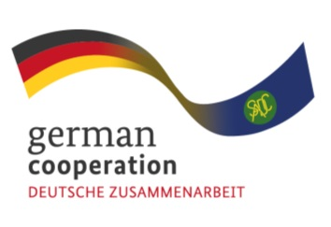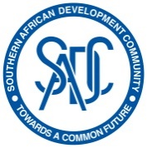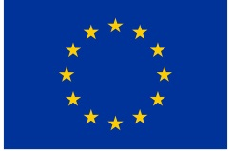

**Contract 83432708**

**Invitation to tender advert:**

**To support development of electronic tendering portal for the Lesotho National Drug Service Organisation (NDSO).**

The Southern African Development Community (SADC) Secretariat, the European Union (EU) and the German Federal Ministry for Economic Cooperation and Development (BMZ) are jointly supporting the “COVID-19-relevant Medical and Pharmaceutical Products” (CMPP), the Antiretroviral (ARV) and Leather regional value-chain (RVC) projects. These RVCs are part of the Joint Action “Support towards Industrialization and the Productive Sectors in the SADC region (SIPS) project. The overall objective of this regional assignment is to support initiatives aimed at enhancing efficiency within Central Medical Stores of the SADC region with regards to information sharing with suppliers and execution of relevant procurement processes and in this case, build capacity in supply chain processes at the Lesotho National Drug Service Organisation (NDSO).

The public market, through government departments or Central Medical Stores are the major buyers of medical and pharmaceutical products, including ARVs. The Joint Action SIPS aims to support Central Medical Stores in the SADC region in availing quality information to suppliers on their requirements and ensuring operational efficiencies as a way of ensuring that the private sector collaborates effectively with this segment of the market thereby enhancing the value chain. Working with Central Medical Stores on improving procurement processes is a step towards increasing market access by the private sector and enhancing internal processes of the Central Medical Stores.

Findings from the inception phase of the Joint Action SIPS revealed that pharmaceutical manufacturers and suppliers lack market information and this initiative aims to increase access to information and ultimately market access by pharmaceutical manufacturers.

It is against this backdrop, that the Joint Action SIPS invites competent and qualified companies of website developers for this assignment to support the development of electronic tendering portal for the Lesotho National Drug Service Organisation (NDSO).

**Submission deadline**

Kindly submit your bid no later than 17th March 2023, 1700hrs, to BW_Quotation@giz.de email comprising of (i) technical offer and (ii) price offer. Please note that tender bids received after the stipulated time, date will not be accepted.

**Please note that this is a regional tender for SADC region-based companies only.**