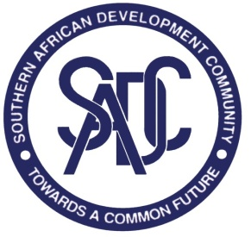

**SADC SECRETARIAT RESPONSES TO REQUESTS FOR CLARIFICATIONS**

**REFERENCE NUMBER: SADC/3/5/4/70**

**CONTRACT TITLE: SUPPLY AND DELIVERY OF MICROSOFT LICENSES FOR THE SADC SECRETARIAT**

**DATE OF ISSUE OF RESPONSES: 27th June 2023**

|  |  |  |
| --- | --- | --- |
| **Q No.** | **Question** | **Response provided by SADC Secretariat** |
| 1 | Kindly Clarify, if you want NEW Microsoft Licenses Or RENEWALS? | **RENEWAL**. We have 300 licenses; however, we are in the process of acquiring 244 new license for two months. These will be renewed together with the current 300 licenses, making a total of 544 license for M365 E3. Hence the quantity is 544. |
| 2 | I would like to enquire whether the reference SADC/3/5/4/70 bid is only subjected to companies in Botswana or open to SADC neighboring countries? | The tender is open to all bidders from all over the world. |

End of Responses

Southern African Development Community

CBD Plot 54385

Phone: (267) 395 1863 | Fax: (267) 397-2 848