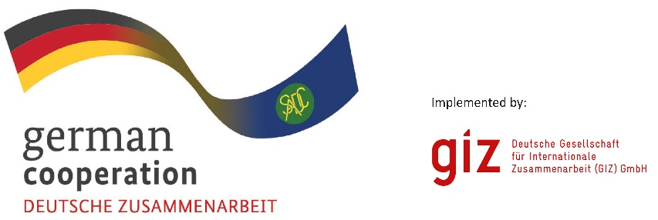

**NOTICE**

**TENDER CANCELLATION**

Notice is hereby given to all bidders of the cancellation of:

**TENDER NO:**

83483086 08/02/2025

**TENDER DESCRIPTION:**

Expression of Interest: Leather Value Chain Mapping Study & Facilitation of B2B Workshop

**REASON FOR CANCELLATION**

Change of Project scope