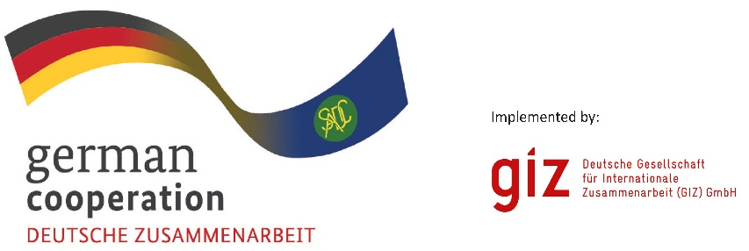

**CALL FOR EXPRESSION OF INTEREST**

**Leather Value Chain Mapping Study & Facilitation of B2B Workshop**

The program "Cooperation for the Enhancement of Southern African Development Community (SADC) Regional Economic Integration" (CESARE III) supports the Southern Africa Development Community (SADC) in its goal to strengthen regional economic integration and development and thereby contribute to the SADC industrialisation and regional integration agenda. Its main cooperation partner is the SADC Secretariat in Gaborone, Botswana. The program is further implemented in cooperation with the national governments of SADC member states and with associations and companies of the private sector and civil society. One of the focus areas of the program is to enhance private sector participation in the region and support regional economic integration in the areas of trade and industrialization through the development of value chains within the agro-processing, pharmaceutical and medical products sectors.

The leather value chain would like to commission a mapping study in 2025. The main objective of the assignment is to

1. Conduct a mapping study of the leather value chain to understand the landscape, gain market intelligence of who the active players are, what their role is and where they are operating from, as well as identify gaps in the value chain.
2. Facilitate a business-to-business (B2B) workshop.

GIZ invites qualified Consulting Firms or Consortium who meet the following requirements to express their interest for the assignment:

1. Conduct research of essential inputs (e.g. but not limited to raw hides and skins), consumables, chemicals and other services (e.g. waste and quality management) required to produce leather and leather products.
2. Identify and map key input market stakeholders (suppliers of inputs/raw materials) and output market stakeholders (buyers and distribution entities) relevant for the LVC. Include a focus on understanding gender representation among these stakeholders.
3. Conduct a detailed analysis on gender mainstreaming in the regional leather value chain by identifying the status, identifying gaps/shortcomings and provide recommendations to enhance the participation of women and marginalized groups in the value chain.
4. Organize, and implement, by inviting participants, moderating and monitoring a B2B workshop to connect LVC companies with the stakeholders identified in (b) above, thereby enhancing their access to input and output markets, while ensuring the inclusion of diverse groups, especially women and youth**.**

Eligible bidders must demonstrate the following:

1. Concept Note (one page)
2. Average annual turnover for the last 3 financial years of at least EUR 40,000.00 or local currency equivalent
3. Average number of employees and managers for the past 3 calendar years of at least 2 persons
4. At least 2 reference projects in Business Consultancy preferable in the leather sector
5. At least 3 reference projects in SADC, ECOWAS and EAC in the last 3 years.
6. Company profile, Tax clearance certificate and Certificate of incorporation/ Consortium agreement.

**Submission deadline**

Bidders from the African Continent are invited to submit their Expression of interest.

Interested parties wishing to participate in this preliminary selection are to submit their documents as stipulated above (1-6), with the subject matter: “***Call for Expression of Interest, Ref “Leather Value Chain Mapping Study & Facilitation of B2B Workshop* No.** **83483086**” to: BW_Quotation@giz.de latest by 5th March 2025 at 23:00hrs local time.

**Please note documents received after the stipulated time, and date will not be accepted**

**Only bidders that have passed the eligibility stage will receive the full tender documents.**