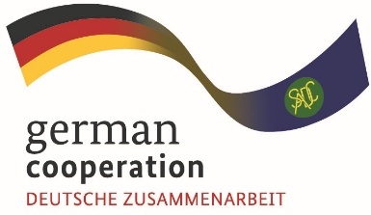
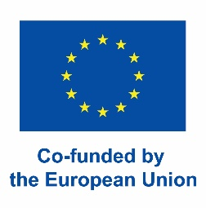
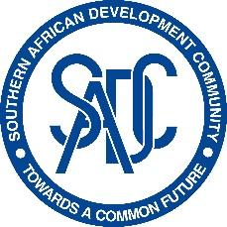

Development of Regional SADC Strategies, Action Plans and Policy Papers for the Fisheries and Aquaculture Sector
The Global Programme “Sustainable Aquatic Food” is implemented by the Deutsche Gesellschaft für Internationale Zusammenarbeit (GIZ) GmbH as part of the German Government special initiative “Transformation of Agricultural and Food Systems”, that aims to facilitate small-scale producers to successfully contribute to the transformation of agricultural and food systems. The programme is being implemented in Malawi, Madagascar, Uganda, Zambia, and has recently started the Southern African Development Community (SADC) component. The SADC component is co-funded by the European Union (EU) as part of the “Blue Benguela Current Action” (BCCA) and it supports the SADC-Secretariat (Food and Natural Resources FANR-Directorate) in three outputs; 1) development of regional policies on sustainable management of fisheries including recognition of small-scale fishermen, 2) capacity strengthening of ten (10) small-scale fisheries organisations (SSF) and 3) support Operations of the SADC Monitoring, Control and Surveillance Coordination Centre (MCS-CC).

This tender focuses on output 1, and has three different but interlinked work packages: (a) Development of a SADC policy paper on WTO agreement on fisheries subsidies and establishment of a regional working group (b) Situation Analysis of the Domestication and Implementation of the Voluntary Guidelines for Securing Sustainable Small-Scale Fisheries in the SADC Region and the Development of a Regional Plan of Action (c) Revision of the SADC Regional Aquaculture Strategy and Action Plan (2016-2026).

The Deutsche Gesellschaft für Internationale Zusammenarbeit (GIZ) GmbH is therefore inviting interested service providers/ consulting companies registered within SADC Member States to apply for this regional assignment. The selected service provider will enter a contract with GIZ.
The procedure will follow a negotiated award with competitive tender. Kindly submit your self-declaration by 08 April 2026, 17.00hrs by email submission at BW_Quotation@giz.de. Following an eligibility assessment the successful companies will be invited to submit their bid, comprising (i) a technical offer and (ii) price offer. Please note that tender bids received after the stipulated time, date will not be accepted. All questions/clarifications should be sent only in writing to BW_Inquiry@giz.de and remember to include in the subject our transaction number 001004704 for our reference.
Interested parties wishing to participate in this tender are to submit their documents with the subject: “Development of Regional SADC Strategies, Action Plans and Policy Papers for the Fisheries and Aquaculture Sector - contract 001004704”. Please find tender documents in the link https://www.giz.de/en/regions/africa/southern-african-development-community-sadc-and-botswana/tenders

