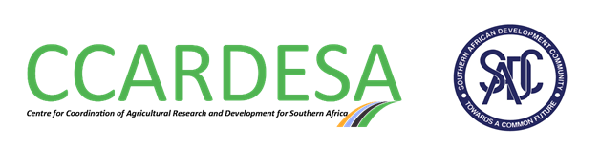 Request for Expression of Interest

Centre for Coordination of Agricultural Research and Development for Southern Africa (CCARDESA)

LEAST COST SELECTION
Assignment Title: Engagement of a Firm to recruit CCARDESA Executive Director- CCARDESA Secretariat, Botswana.
The Centre for Coordination of Agricultural Research and Development for Southern Africa (CCARDESA) has received financing from various donors towards its mandate of Coordinating Agricultural Research and Development in Southern Africa and intends to apply a portion of these proceeds towards eligible payments under this contract. Payment by CCARDESA will be made only against approved deliverables, and will be subject, in all respects, to the terms and conditions of the CCARDESA financial Management Systems.
The primary objective of this assignment is to assist the Board of Directors of CCARDESA in recruiting a highly qualified, experienced, and honest professional for the position of Executive Director of CCARDESA.
In undertaking the assignment, the consultant will, amongst others, perform the following:
- Assist the Board of CCARDESA and the Secretariat to advertise the position of Executive Director of CCARDESA widely in the region and beyond;
- Receive applications and compile a list of all the applicants;
- Conduct initial vetting of the applicants based on the CVs submitted and the terms of reference for the position;
- Use a range of innovative tools, including electronic interviews, to identify the top 10 candidates;
- Write a detailed report documenting the process followed and how the firm arrived at the top 10 candidates; and
- Submit the report, along with the 10 shortlisted candidates, to the Chairperson of the Board of Directors of CCARDESA
The Centre for Coordination of Agricultural Research and Development for Southern Africa now invites eligible Consulting Firms (“Consultants”) to submit their proposals towards the provision of the Services. Interested consultants should provide information (Comprehensive list of assignments showing description of similar assignments, Management Structure, experience in similar conditions) demonstrating that they have the required qualifications and relevant experience to perform the Services.
The best qualified firm to carry out the services will be selected in accordance with the Least Cost (LCS) method set out in the CCARDESA procurement manual and based on the following criteria: The shortlisting criteria are:
- At least 8 years of experience in the recruitment of Chief Executives and senior managers, especially within the SADC region
- Evidence of highly qualified experts who will lead the process of recruitment
- Domicile/registration in the SADC region
- Traceable knowledge of the SADC region and its cultural and religious diversity
- Ability to work efficiently and deliver the results on time

Further information (terms of reference) can be obtained at the address below during office hours 0900 to 1630 hours.
Technical and Financial Proposals must be delivered in a written form to the address below (in person, or by mail, or by e-mail) not later than 22nd June 2026. Applications should bear the name of the assignment in the subject field.
The Procurement Officer
Centre for Coordination of Agricultural Research and Development for Southern Africa (CCARDESA) Secretariat
Ground Floor, Red Brick Building
Plot 4701
Station Exit Road
Private Bag 00357
Gaborone, Botswana
E-mail: procurement@ccardesa.org
Tel: 3914997
Website: https://www.ccardesa.org/procurement

