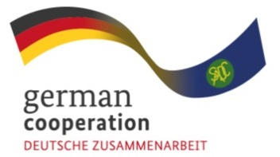
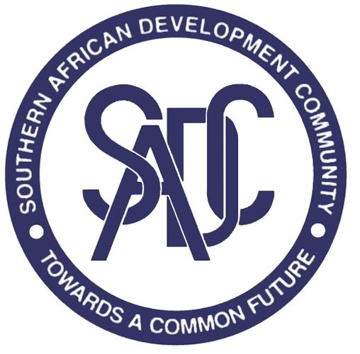
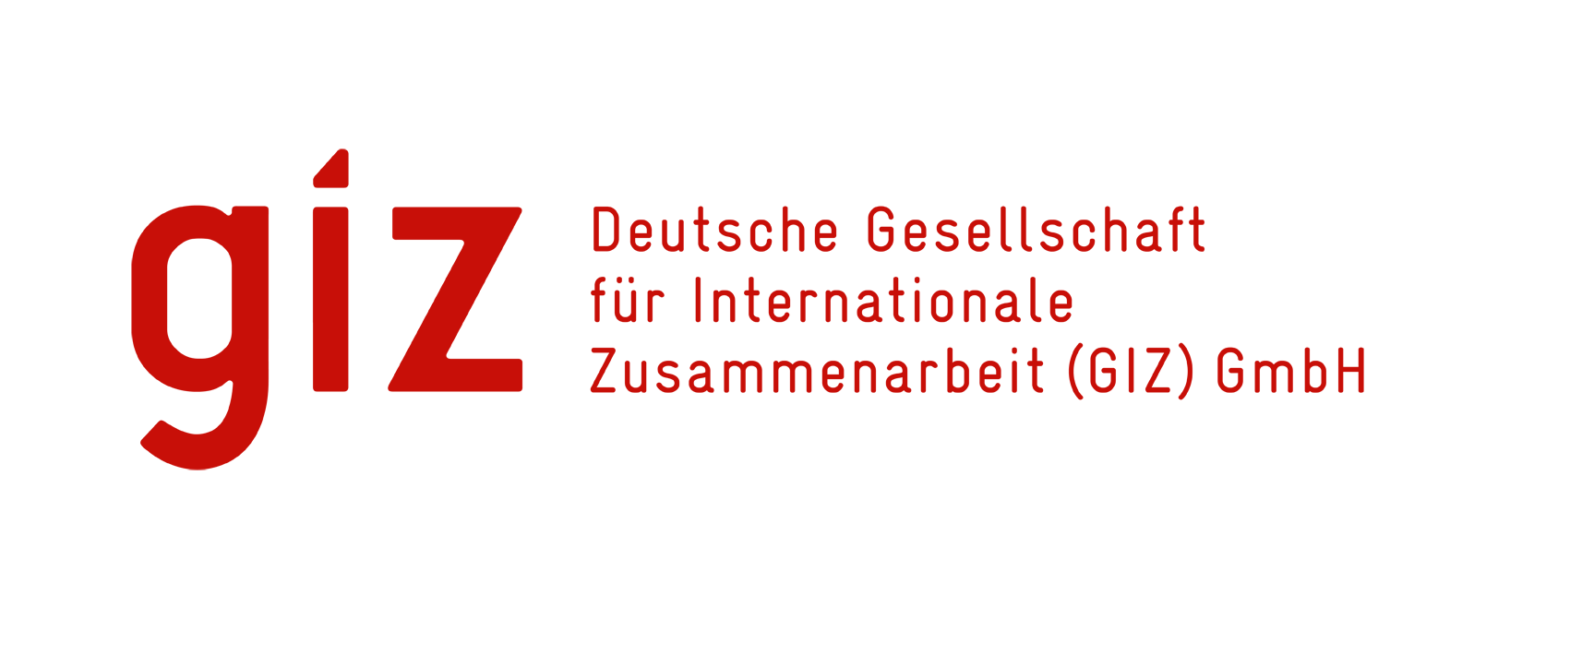
Implemented by

STRENGTHENING THE NATIONAL-REGIONAL LINKAGES IN SADC (SNRL) PROGRAMME

APPLICATION GUIDANCE, NARRATIVE PROPOSAL AND BUDGET TEMPLATES

Table of Contents
List of Tables iii
List of Acronyms and Abbreviations iv
PART A: APPLICANT GUIDANCE 1
A.1 Background 1
A.2 Rationale for the Call for Proposals 1
A.3 Target group 2
A.4 Thematic areas of focus 2
A.4.1 SADC regional integration communication strategies 2
A.4.2 Development of SADC success stories 3
A.5 Types of activities supported 3
A.6 Expected impact 3
A.7 Eligibility 3
A.8 Selection criteria 3
A.9 General framework conditions and timelines 5
A.10 Disclaimer 6
A.11 How to apply 6
A.12 Guidance for National Contact Points 6
PART B: APPLICATION 8
B.1 Administrative and organisational information 8
B.2 Selection of thematic area 8
B.3 General information on the proposed project 8
B.4 Project outline 9
B.5 Implementation schedule 9
B.6 Project management and institutional arrangements 10
B.7 Contribution to SNRL Programme results 10
B.8 Project budget 10
B.9 Declaration and endorsement 11

List of Tables

Table 1: Selection criteria and weightings 5
Table 2: Key dates for the Call for Proposals 5
Table 3: Summary of Member State responses to the Call for Proposals 7

List of Acronyms and Abbreviations

Acronym | Meaning
ADA | Austrian Development Agency
CAT | Central Africa Time
CfP | Call for Proposals
CPRU | Communications and Public Relations Unit
EU | European Union
EUR | Euro
GIZ | Deutsche Gesellschaft für Internationale Zusammenarbeit
MDA | Ministry, Department or Agency
NCP | National Contact Point
RISDP | Regional Indicative Strategic Development Plan
SADC | Southern African Development Community
SNMC | SADC National Media Coordinator
SNRL | Strengthening National-Regional Linkages in SADC Programme
ToR | Terms of Reference

STRENGTHENING NATIONAL-REGIONAL LINKAGES IN SADC (SNRL) PROGRAMME CALL FOR PROPOSALS: SUPPORT TO SADC MEMBER STATES FOR THE DEVELOPMENT OF COMMUNICATION STRATEGIES AND SUCCESS STORIES APPLICATION GUIDANCE, NARRATIVE PROPOSAL AND BUDGET TEMPLATES

PART A: APPLICANT GUIDANCE

This document guides the principal target groups of the Strengthening National-Regional Linkages in SADC (SNRL) Programme in the Member States in preparing a response to the Call for Proposals (CfP) announced through the website of the Secretariat of the Southern African Development Community (SADC) and through direct communication with the National Contact Points. The guidance set out in Part A will assist applicants in completing the application contained in Part B of this document.

A.1 Background

The SNRL Programme, co-funded by the German Government, the Austrian Development Agency (ADA) and the European Union (EU), supports the SADC Secretariat and Member States in improving institutional frameworks and monitoring and evaluation systems for the implementation of regional integration agenda. The Programme also supports efforts to improve knowledge and awareness raising on SADC related topics among the public in the SADC region.

Despite the progress achieved through regional integration efforts, awareness among citizens and stakeholders of the impact, benefits and opportunities arising from SADC programmes remain limited in many Member States. There is therefore a growing need to strengthen communication and visibility efforts at national level so that citizens better understand and appreciate the value and relevance of regional integration.

This Call for Proposals invites SADC Member States to submit expressions of interest for technical support in two focus areas, namely the development of national gender-sensitive communication strategies and the development and documentation of SADC success stories. Support under this Call is provided as direct technical assistance from the SNRL Programme. No financial grants are provided.

A.2 Rationale for the Call for Proposals

The CfP approach adopted by the SNRL Programme is underpinned by two main considerations. First, there are limited resources available for the funding of activities envisaged under the current phase of the Programme. In the light of these considerations, it is clear that the SNRL Programme will not be in a position to support every request emanating from the Member States and a basis for competitive selection is accordingly required.

Secondly, the approach is intended to ensure that support is demand driven, transparent, fair and responsive to the varying capacities and needs of Member States. Across the SADC region, Member States demonstrate differing levels of institutional and technical capacity in communicating the benefits, opportunities and impact of regional integration initiatives. The Call for Proposals mechanism provides an equitable platform through which Member States may express interest and articulate their specific communication and visibility needs aligned to the SADC Communication, Awareness and Visibility Strategy 2025-2030.

A.3 Target group

Applicants are the state institutions of Member States that carry responsibility for coordinating and implementing the regional integration agenda, and those mandated to coordinate media engagement at national level. Proposals are prepared by the experts and managers of those institutions and are submitted in the name of the institution. The following entities are eligible for support under this Call:

- SADC Member States;
- National Contact Points (NCPs);
- Ministries of Information and Communication, including the offices of the National Media Coordinators (SNMCs); and
- Relevant government institutions coordinating SADC programmes at national level.

A.4 Thematic areas of focus

The Call for Proposals is confined to two thematic areas that contribute to Output 3 of the SNRL Programme: strengthened awareness, visibility and public understanding of SADC regional integration and its benefits at Member State level. Output 3 supports Member States to communicate SADC priorities, programmes, achievements and opportunities more effectively to citizens, stakeholders and the media.

Under this Call, support is available for:
- the development of national gender-sensitive SADC communication strategies; and
- the development, documentation and dissemination of SADC success stories.
Applications that fall outside these two areas will not be considered.

A.4.1 SADC regional integration communication strategies

The Programme will support Member States in strengthening their strategic communication capacities so that they are able to disseminate information on SADC related activities and the results arising from them. Support in this area will take the form of the development of national gender-sensitive SADC communication strategies that complement the work of the National SADC Coordinators in raising awareness of SADC integration processes. National SADC Media Coordinators are particularly targeted in order to strengthen their championing role at Member State level. National strategies must be aligned to the SADC Communication, Awareness and Visibility Strategy 2025-2030, and the Communications and Public Relations Unit (CPRU) of the SADC Secretariat will take part in their review and validation. In line with the gender mainstreaming approaches of SADC and of the Programme, communication strategies must provide for the inclusion of women and young people in their implementation.

A.4.2 Development of SADC success stories

Support in this area is aimed at assisting Member States to document and disseminate compelling success stories that demonstrate the contribution of SADC to socio-economic development, and to promote the visibility of SADC achievements among citizens, stakeholders and policy makers. Support may include the development of written, photographic, and multimedia success stories, and the packaging of those stories in engaging and accessible formats tailored to their intended audience for dissemination through national and regional communication platforms. Success stories should highlight tangible outcomes and benefits arising from SADC interventions within the Member State.

A.5 Types of activities supported

The types of activity that may be supported through this Call for Proposals are the following:
- story development and consultations;
- packaging and dissemination of communication products; and
- capacity development directed at the individual, organizational and systemic levels.

A.6 Expected impact

Support to Member States in the development of communication strategies and the documentation of success stories is expected to strengthen awareness, visibility and public understanding of regional integration initiatives and their benefits. Through strengthened communication strategies, Member States will be better equipped to communicate SADC priorities, programmes, achievements and opportunities to citizens, stakeholders and the media in a more coordinated and impactful manner. Support for the development and dissemination of success stories will further contribute to demonstrating the relevance and benefits of regional cooperation in improving livelihoods, economic opportunities, trade, infrastructure, peace and security and other priority areas.

A.7 Eligibility

The Call for Proposals is open to state actors from all sixteen SADC Member States that play a role in the coordination of regional integration activities, particularly in the areas of communication and awareness raising. It remains open to line ministries within Member States to include the participation of Non-State Actors in the implementation of a proposal where this is considered appropriate.

A.8 Selection criteria

A key selection criterion is demonstrated need for technical assistance, assessed against the existing institutional and technical capacities of the Member State. Priority will be given to Member States that exhibit weak or limited capacity in communicating and showcasing the benefits of SADC regional integration initiatives. Weak capacity may include the absence of a dedicated communication strategy, a low frequency of awareness and visibility initiatives, inadequate systems for documenting and disseminating success stories, weak engagement with the media and stakeholders, and limited experience in developing communication products that highlight the national impact of SADC programmes.

In line with the Programme’s commitment to equitable access to support across the SADC region, the assessment will give particular consideration to Member States with comparatively limited institutional and technical capacity in the relevant thematic area. The Selection Committee may take account of the existence and implementation status of national SADC communication strategies, the availability of communication and visibility systems, prior access to comparable SNRL support, and demonstrated institutional readiness. Where proposals are otherwise comparable, priority may be given to Member States that have not previously benefited from comparable SNRL Call for Proposals support or that demonstrate a more significant capacity gap.

This preserves open eligibility while allowing the Committee to prioritise weaker-capacity Member States rather than applying a rigid exclusion rule.

The specific criteria applied to applications are set out below. Applications will be assessed against these criteria using a structured scoring matrix, and the results of that assessment will inform the decision of the Selection Committee. Eligibility is assessed first, on a pass or fail basis, against the requirements in section A.7 and against the requirement that the proposed intervention be of a technical assistance nature falling within one or both of the two thematic areas. Proposals seeking grants, or falling outside the two thematic areas, will not be supported and will not proceed to scoring.

- The proposal must be realistic, coherent and aligned to the Member State implementation plan of the Regional Indicative Strategic Development Plan (RISDP), and must contribute to the targeted outcomes of that plan, of the SADC Communication, Awareness and Visibility Strategy 2025-2030 and of the SNRL Programme.
- The proposal must demonstrate clear potential impact on awareness raising for the country and, where applicable, the region.
- The proposal must demonstrate the integration of gender considerations in the design and implementation of the proposed activities.
- The proposal must demonstrate elements of inclusiveness in its implementation.
- The proposal must demonstrate how the results will be sustained within the Member State beyond the period of SNRL support.
- The applicant must demonstrate commitment to designate a focal team that will lead the implementation of the project.
- The applicant must demonstrate need for support, institutional commitment and ownership of the proposal.
- The applicant must indicate whether it has a national SADC communication strategy and, where one exists, the extent to which it is aligned to the SADC Communication, Awareness and Visibility Strategy 2025-2030, where applying under thematic area A.4.1.
- The applicant must indicate the extent to which it has previously documented and published SADC success stories, where applying under thematic area A.4.2.
- The applicant must indicate existing communication arrangements, communication challenges and intended target audiences.
- The applicant must indicate existing SADC initiatives in the country, potential success stories and the availability of beneficiaries.
- The proposal must be sufficiently detailed in respect of activities, timeline, responsible personnel and budget to permit implementation to commence directly upon selection, without a further round of project development.

Table 1 sets out the selection criteria that will be used by the Selection Committee.

Table 1: Selection criteria and weightings

Selection criterion | Weight | Assessment focus
Strategic alignment and coherence | 25% | Alignment with the RISDP national implementation plan, the SADC Communication, Awareness and Visibility Strategy 2025–2030, and SNRL objectives
Demonstrated need and institutional commitment | 20% | Capacity gap, equity considerations, institutional ownership, focal-team commitment, and relevant prior support
Potential impact on awareness and visibility | 20% | Expected reach, relevance, and likely contribution to awareness of SADC regional integration
Implementation readiness | 15% | Feasible activities, timeline, responsible personnel, administrative arrangements, and indicative budget
Gender sensitivity and inclusion | 10% | Integration of gender considerations and meaningful inclusion of women, young people, and relevant groups
Sustainability and continued use of results | 10% | Measures to sustain, institutionalise, disseminate, and use results after SNRL support
Total | 100%

Each criterion will be scored on a scale of zero to five, and weighted scores will be aggregated. Before evaluation begins, the Selection Committee will set a minimum threshold score below which a proposal will not be recommended for support, irrespective of its ranking.

A.9 General framework conditions and timelines

The submission window will be four weeks from the date on which the Call for Proposals is advertised. Screening and technical evaluation will be completed within two weeks of the closing date, the Selection Committee will sit within a further week, and successful and unsuccessful applicants will be notified within one week of the decision of the Committee. Implementation will commence on the basis of the approved proposal, and no further round of project development will be undertaken.

Applications are assessed on the understanding that a selected proposal proceeds directly to implementation. Applicants should therefore ensure that the activity schedule, institutional arrangements and budget submitted in Part B are sufficiently detailed to be implemented without further project development.

The dates applicable to this Call are set out in Table 2.

Table 2: Key dates for the Call for Proposals
Milestone | Date
Notification of Member States | 20 August 2026
Public advertisement and official launch of the Call | 24 August 2026
Orientation session for Member States | 28 August 2026
Final date for enquiries | 14 September 2026
Closing date for applications | 21 September 2026, 17:00 CAT
Screening and technical evaluation | 22 September–2 October 2026
Selection Committee sitting | 6 October 2026
Notification of applicants | 8–9 October 2026
Commencement of implementation | From 26 October 2026

A.10 Disclaimer

The submission of a proposal does not confer any legal entitlement to receive services from the SNRL Programme. Any advisory services or technical assistance provided under this Call for Proposals will be granted following, and in accordance with, appropriate legal and commercial review, in particular with regard to the public benefit purpose of each project. Overall compliance may also require adjustments to the concept of the proposal submitted, as well as the inclusion of corresponding provisions in the agreements governing the assistance provided by the SNRL Programme.

A.11 How to apply

Applicants must complete Part B of this document. Completed applications are submitted through the National Contact Point to snrl@giz.de. Templates may be obtained from the SADC Secretariat website or from the National Contact Point. The deadline for submissions is 21 September 2026 at 17:00 hours CAT. Applications may be submitted in English, French or Portuguese.

A.12 Guidance for National Contact Points

National Contact Points are responsible for transmitting the Call for Proposals and the related instruments to the lead ministries and other government departments and agencies, and for consolidating the responses for submission to the SNRL Programme. National Contact Points are encouraged to take the following steps.

Step 1: on receipt of the announcement of the Call for Proposals and the application and budget templates, the NCP must transmit the documents to the contact points in each lead ministry and government department or agency, together with a short explanatory note on what the Call entails. Further clarification may be sought from the SNRL Programme.

Step 2: NCPs must engage in information sharing and communication. It is important to encourage MDAs in developing a response that adequately addresses the requirements of the Call.

Step 3: the NCP must set an internal deadline for the submission of applications that falls before the deadline stated in the announcement and must remind potential applicants periodically as that deadline approaches. Sufficient time must be available for the consolidation of applications.

Step 4: the NCP must collect the responses from the various government departments and agencies and consolidate them into a single package for submission to the SNRL Programme, using the summary table set out in Table 3. The detailed application of each applicant must be attached, using Part B of this document.

Table 3: Summary of Member State responses to the Call for Proposals

Name of country
Details of the National Contact Point
Names of the lead ministries, government departments or agencies that prepared a response
Names of the contact persons in the lead ministries or government agencies
Number of submissions attached
Thematic areas in which support is required | Please indicate the number of applications submitted under each thematic area.
Thematic area 1: SADC regional integration communication strategies
Thematic area 2: Development of SADC success stories

PART B: APPLICATION
This part is completed by the applicant. Word limits are indicated for each field and should be observed. Applications should be complete and implementation ready, since selected proposals proceed directly to implementation without a further round of project development.

B.1 Administrative and organisational information

Name of country
Details of the National Contact Point
Name of the lead ministry, government department or agency
Name and position of the contact person in the lead ministry, department or agency
Contact details, being telephone and electronic mail
Principal areas of focus of the lead ministry, department or agency | (maximum 100 words)
Experience of the lead ministry, department or agency with comparable support from the SNRL Programme or the SADC Secretariat | (maximum 200 words)
Does the Member State have a national SADC communication strategy in place? If so, please state the year of adoption. | (maximum 100 words)
Has the Member State published SADC success stories? If so, please state how many and in which formats. | (maximum 100 words)

B.2 Selection of thematic area

Please select the thematic area applicable to your application. A separate application is required for each thematic area.

Thematic area | Selection
SADC regional integration communication strategies
Development of SADC success stories

B.3 General information on the proposed project

Project title
Short description of the project, including the expected impact, the activities and the beneficiaries | (maximum 200 words)
Indicative value of the technical support requested, in euros
Proposed duration of the project
Proposed start date | Please indicate when the project will be ready for implementation.

Support under this Call is provided as direct technical assistance and not as grant funding. The indicative value requested is used for planning purposes only.

B.4 Project outline

Justification and context. Describe the communication and visibility challenge in the target area that the project will address. | (maximum 400 words)
Specific objectives. Please describe the specific objectives that the project seeks to achieve. | (maximum 200 words)
Key activities. Please describe the key activities that will contribute to achieving the objectives outlined above. | (maximum 200 words)
Beneficiaries. Describe the target beneficiaries. State also the criteria by which the beneficiaries are selected and how that selection is fair, non-discriminatory and transparent. | (maximum 150 words)
Expected results and impact on awareness raising. Describe the results expected for the target beneficiaries and the anticipated effect on awareness of SADC regional integration. | (maximum 300 words)
Gender and inclusion. Describe how gender considerations and the inclusion of women and young people are integrated into the design and implementation of the project. | (maximum 250 words)
Alignment to national and regional frameworks. Describe the alignment of the project to national development priorities, to the national implementation plan of the RISDP and to the SADC Communication, Awareness and Visibility Strategy 2025-2030. | (maximum 400 words)
Risk and mitigation. Identify the principal risks to implementation and the measures proposed to mitigate them. | (maximum 300 words)
Sustainability and regional learning. Please describe how the results will be sustained beyond the period of SNRL support, and how the experience may inform other Member States. | (maximum 300 words)

B.5 Implementation schedule

Please set out the activities to be implemented, the period in which each will take place and the party responsible. This schedule forms the basis of implementation should the proposal be selected and should therefore be realistic and complete. Additional rows may be inserted as required.

No. | Activity | Period (month and year) | Responsible party
1
2
3
4
5

B.6 Project management and institutional arrangements

Responsible official. Provide the name and position of the official who will be accountable for the delivery and results of the project. | (maximum 50 words)
Focal team. Provide the composition of the focal team that will lead implementation, indicating the role of each member. | (maximum 150 words)
Key partners. Indicate the entities that will support the lead ministry in implementing the project, including any non-state actors. | (maximum 100 words)
Monitoring and reporting arrangements. Describe how progress will be monitored and reported, including the person or unit responsible and the reporting frequency. | (maximum 200 words)
Administrative arrangements. Indicate any national approvals, or administrative arrangements required before implementation can begin, and the time these require. | (maximum 200 words)

B.7 Contribution to SNRL Programme results

SNRL Programme result | Contribution of the proposed project
Indicator 3.1: Number of gender-sensitive national communication strategies based on the SADC Regional Communication Strategy developed by selected Member States | (maximum 250 words)
Indicator 3.2: Number of SADC success stories published by selected Member States | (maximum 250 words)

Applicants complete the row corresponding to the thematic area selected in section B.2.

B.8 Project budget

Please provide an indicative budget in euros that corresponds directly to the activities in the implementation schedule at section B.5. Applicants may propose the cost categories required for their proposed technical-assistance intervention. Each cost item must identify the unit, quantity, unit rate and total cost.

The budget must be realistic, complete, and sufficiently detailed to permit implementation directly after selection. The indicative budget will be reviewed and finalized with the SNRL Programme during inception and before implementation. Partial financing of a single cost item is not possible.

Proposed cost category | Cost item / basis of calculation | Amount (EUR) | Related activity number
Total indicative cost |  | EUR
Support requested from the SNRL Programme |  | EUR
Applicant contribution, in kind and/or financial | State the contributor, contribution type, valuation, and amount | EUR

Support is provided as direct technical assistance and not as grant funding. Amounts stated are indicative and will be confirmed with the SNRL Programme following selection.

B.9 Declaration and endorsement

I confirm that the information provided in this application is accurate, that the lead ministry, department or agency endorses this proposal, and that the focal team identified at section B.6 will be made available for implementation.

Name and position of the responsible official
Institution
Signature
Date

